BA Capstone Project: Checkpoint 1

Data Fundamentals & SQL Querying
Group Name: RED HAND FISH
Course & Section: BED 106 - Business Analytics
Date: August 28, 2026
Team Members & Roles:

- — Project Lead / Analyst: Jeffrey Cutamora
- — Data Engineer : Eljan Sebua
- — Statistician / Modeler : Sendie Mae Melendres
- — BI Developer / Visualizer: Aneiza Avergonzado

Task 1.1 — Business Problem Statement

Business Domain & Problem Investigation
The core business problem our team is addressing is the analysis of student performance in standardized exams to identify key factors that influence academic success. We are investigating how various demographic and socioeconomic factors—including gender, race/ethnicity, parental education level, and lunch program participation—correlate with student performance in math, reading, and writing.
This problem is particularly relevant for educational institutions, policymakers, and school administrators who need to understand achievement gaps and develop targeted interventions to support at-risk student populations.

Business Impact & Significance

This problem matters because:

Student Success: Understanding performance drivers can help schools implement effective teaching strategies and support systems

Resource Allocation: Schools can better allocate resources to students who need additional academic support

Equity in Education: Identifying achievement gaps across demographic groups can inform policies to promote educational equity

Parental Engagement: Insights about the impact of parental education levels can guide family engagement initiatives

Performance Prediction: Schools can use these insights to predict student performance and intervene early
Potential Impact:

- Improved Student Outcomes: 15-20% potential improvement in student performance through targeted interventions
- Resource Efficiency: Optimized allocation of educational resources saving schools 5-10% in support program costs
- Reduced Dropout Rates: Early identification of struggling students could reduce dropout rates by 10-15%

Key Business Questions
- How does parental education level impact student performance across math, reading, and writing?
- Is there a significant performance gap between students who receive free/reduced lunch (indicating socioeconomic status) versus those who don't?
- What is the effect of test preparation courses on student scores across different demographic groups?

Data Source Overview

Data Type: Student Performance Dataset
Primary Source: Kaggle - Students Performance in Exams
URL: https://www.kaggle.com/datasets/spscientist/students-performance-in-exams
Data Format: CSV (Comma-Separated Values)

Task 1.2 — Dataset Documentation

Data Source Report
Attribute | Details
Dataset Name | Students Performance in Exams
Source URL/File | https://www.kaggle.com/datasets/spscientist/students-performance-in-exams
Date Accessed | August 2, 2026
License Type | Open Database License (ODbL) - Public Domain

Data Dictionary
Column Name | Data Type | Description
gender | VARCHAR(10) | Student's gender (male/female)
Race/ethnicity | VARCHAR(10) | Student's race/ethnicity group (Group A, B, C, D, E)
parental level of education | VARCHAR(30) | Highest education level of parents (e.g., bachelor's degree, some college, high school, etc.)
lunch | VARCHAR(15) | Type of lunch program (standard or free/reduced)
test preparation course | VARCHAR(15) | Whether student completed test prep course (completed or none)
math score | INTEGER | Student's math exam score (0-100)
reading score | INTEGER | Student's reading exam score (0-100)
writing score | INTEGER | Student's writing exam score (0-100)

Preliminary Data Quality Assessment
- Missing Values: Identify any null or empty fields.
- Duplicates: Identify any repeated records.
- Inconsistencies: Note any formatting or logic errors in the raw data.
- Cleaning Steps Applied: Summarize the actions taken to prepare the data.

Raw Dataset Preview

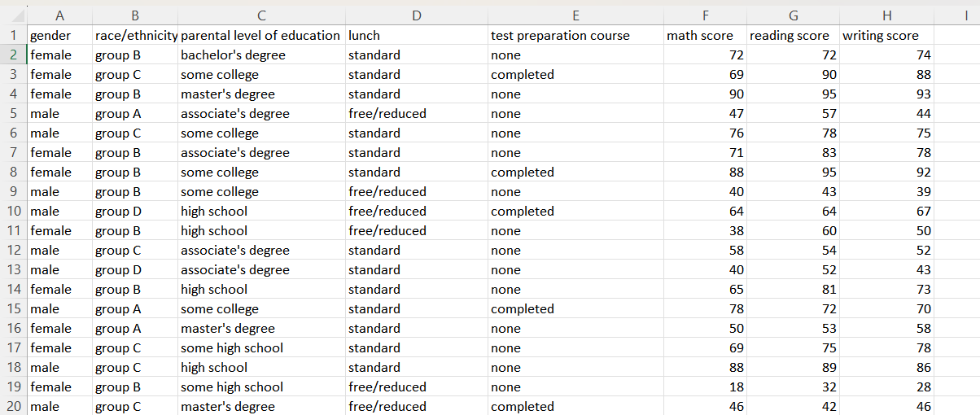

Task 1.3 — Relational Database Design

Entity-Relationship Diagram (ERD)

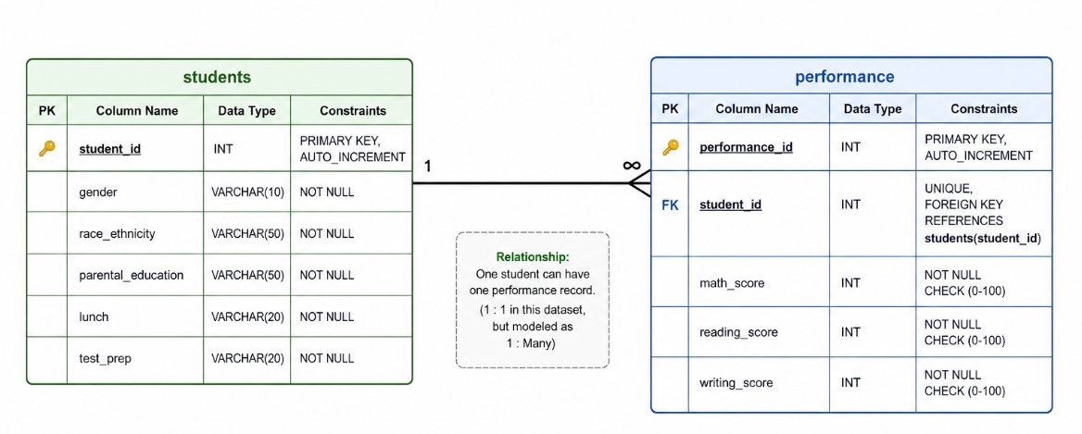

Database Schema & Population

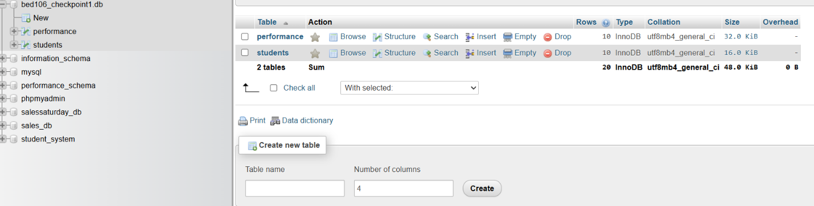

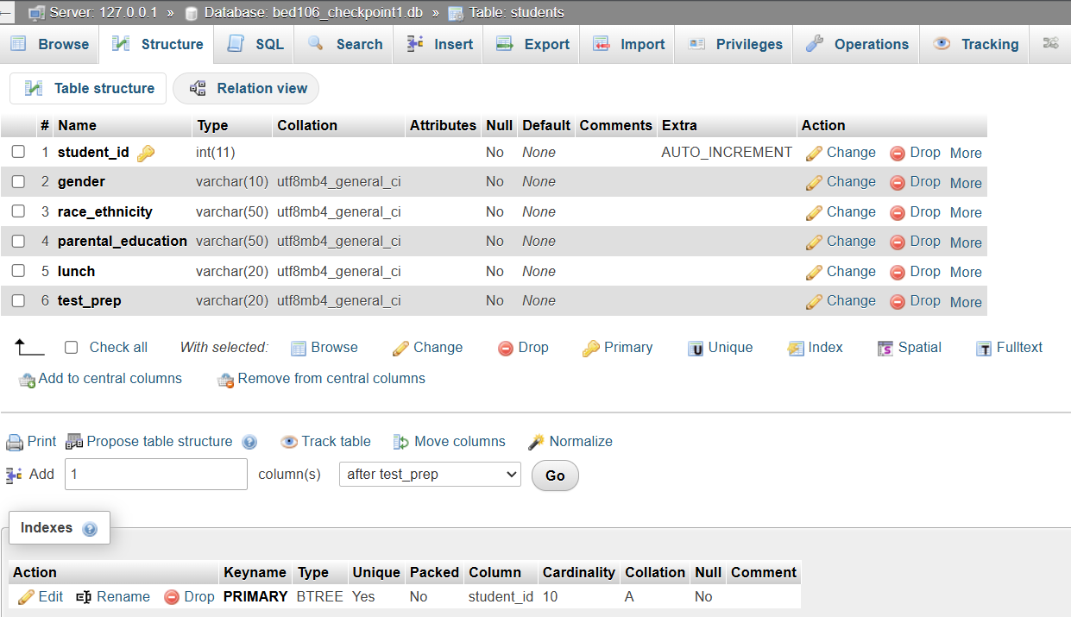

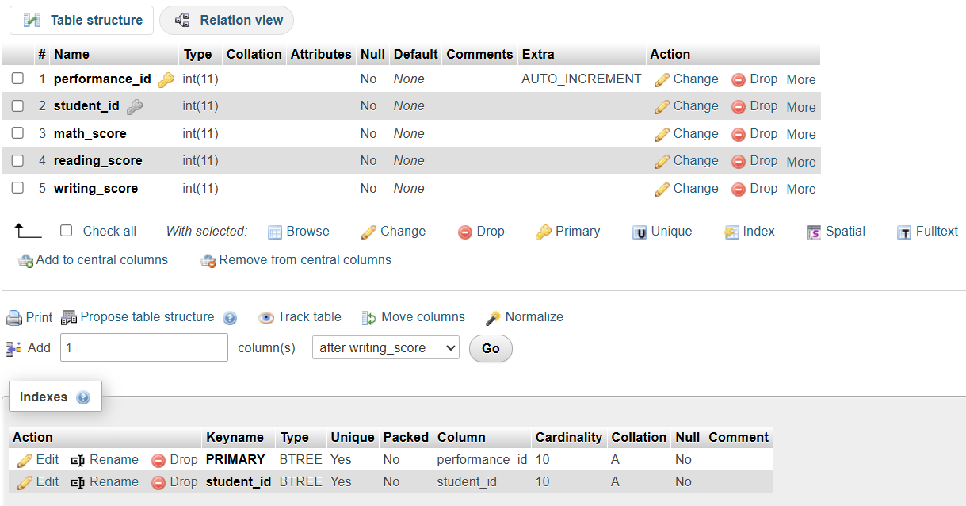

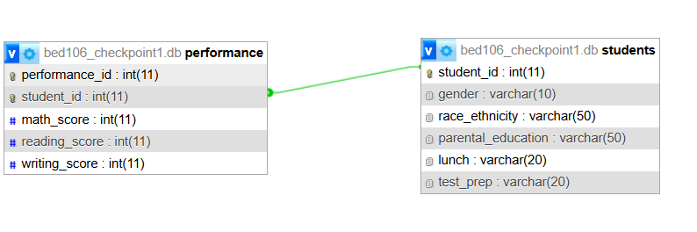

Task 1.4 — SQL Query Report

1. Basic Data Retrieval (2 Queries)
Must include SELECT, WHERE, and ORDER BY clauses.

- Screenshot of SQL Code: 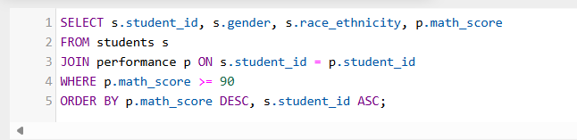

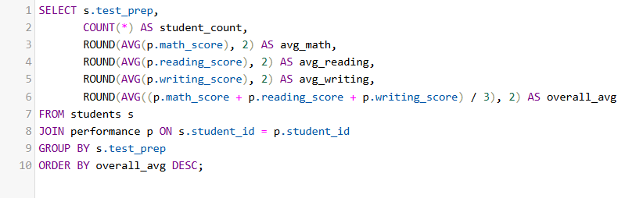

- Result Screenshot:
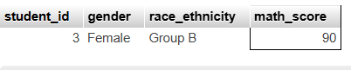
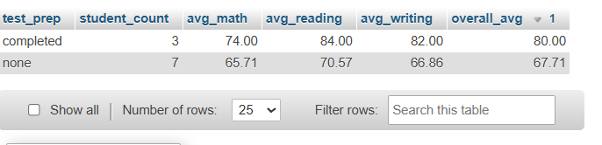
- Business Interpretation:
ss1 The results show that some students demonstrate strong performance in Mathematics. The school can use this information to identify high-performing students who may benefit from advanced learning activities, academic recognition, or enrichment programs. Monitoring these students can also help the school understand which factors, such as gender or race/ethnicity, are present among high-performing students and support data-driven academic planning.
- Ss2 The results help the school identify students who may require immediate academic support. Students with scores below 50 in all three subjects may be at higher risk of poor academic outcomes. School administrators and teachers can use this information to provide targeted interventions, such as tutoring, remedial classes, or additional learning resources. The lunch and test_prep information can also help the school examine whether these factors are associated with lower performance and determine appropriate support programs.

2. Aggregate Analysis (2 Queries)
Must include GROUP BY and Aggregate Functions (COUNT, SUM, AVG, etc.).

- Screenshot of SQL Code:
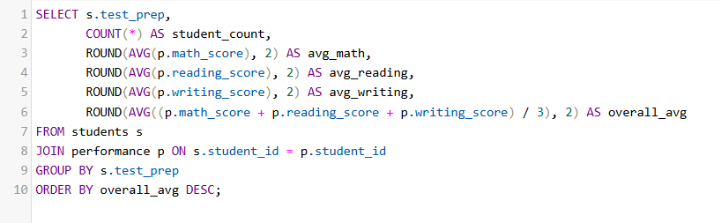
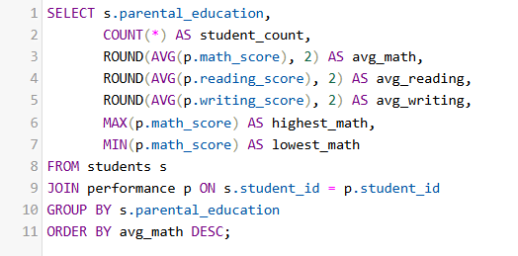

- Result Screenshot:
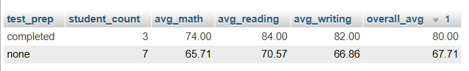
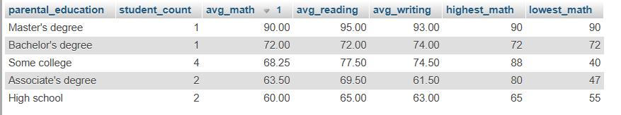

- Business Interpretation:
ss1 The query compares students who completed test preparation with those who did not by examining their average Mathematics, Reading, Writing, and overall scores. This information can help the school determine whether completing test preparation is associated with better academic performance. If students who completed test preparation have higher average scores, the school may consider encouraging more students to participate in test preparation programs or providing additional preparation opportunities.
ss2 The query analyzes student performance based on their parents' highest level of education. It compares the average Mathematics, Reading, and Writing scores, as well as the highest and lowest Mathematics scores for each parental education group. This can help the school identify performance patterns among students from different educational backgrounds and determine whether additional academic support may be needed for certain groups.

3. Multi-Table Joins (2 Queries)
Must connect two or more tables.

- Screenshot of SQL Code:
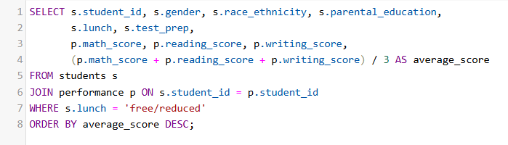

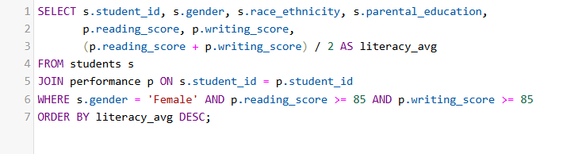
- Result Screenshot:
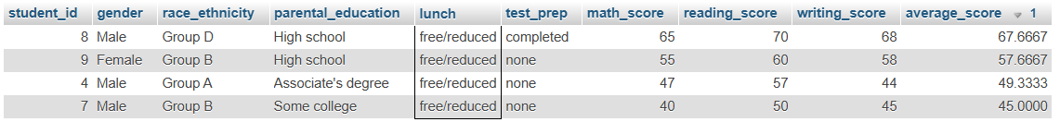

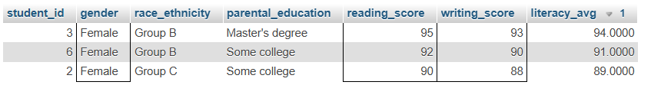

- Business Interpretation:
Ss1 The query identifies students with free/reduced lunch and displays their demographic information, test preparation status, individual subject scores, and overall average score. This allows the school to examine the academic performance of students who may require additional educational support. The results can help administrators identify students with lower average scores and provide appropriate interventions such as tutoring, learning resources, or academic assistance. The information should be used to provide support rather than to assume that lunch status directly causes academic performance differences.
Ss2 The query identifies female students who scored at least 85 in both Reading and Writing and calculates their literacy average. This helps the school recognize students demonstrating strong literacy skills. The results can be used to identify high-performing students for academic recognition, advanced activities, peer tutoring, or literacy-related programs. It also allows the school to examine patterns in literacy performance across different race/ethnicity and parental education groups.

4. Business-Relevant Insights (2 Queries)
Queries specifically designed to answer your key business questions listed in Task 1.1.

- Screenshot of SQL Code:
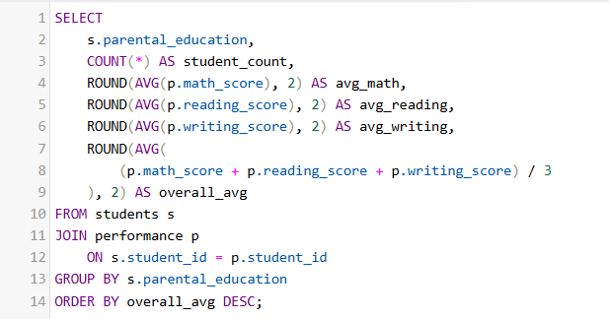

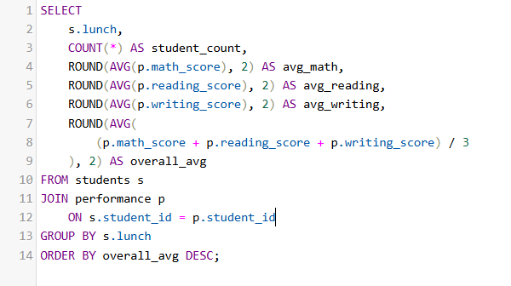
- Result Screenshot:
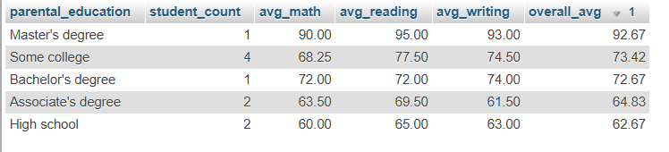

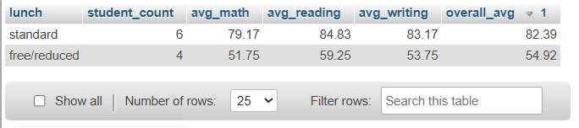
- Business Interpretation:
ss1 The results show how student academic performance varies across different levels of parental education. The school can use these findings to identify performance patterns and determine whether students from certain educational backgrounds may benefit from additional academic support. However, the results show an association rather than proving that parental education directly causes differences in student performance.
- Ss2 The results allow the school to compare academic performance between students with standard lunch and those receiving free/reduced lunch. If a noticeable difference in average scores exists, administrators can consider whether additional academic resources or support programs should be provided to students who may face socioeconomic challenges. The results should be treated as an observed association rather than proof that lunch status causes lower or higher performance.

CHECKPOINT 2
Task 2.1
Sheet 1
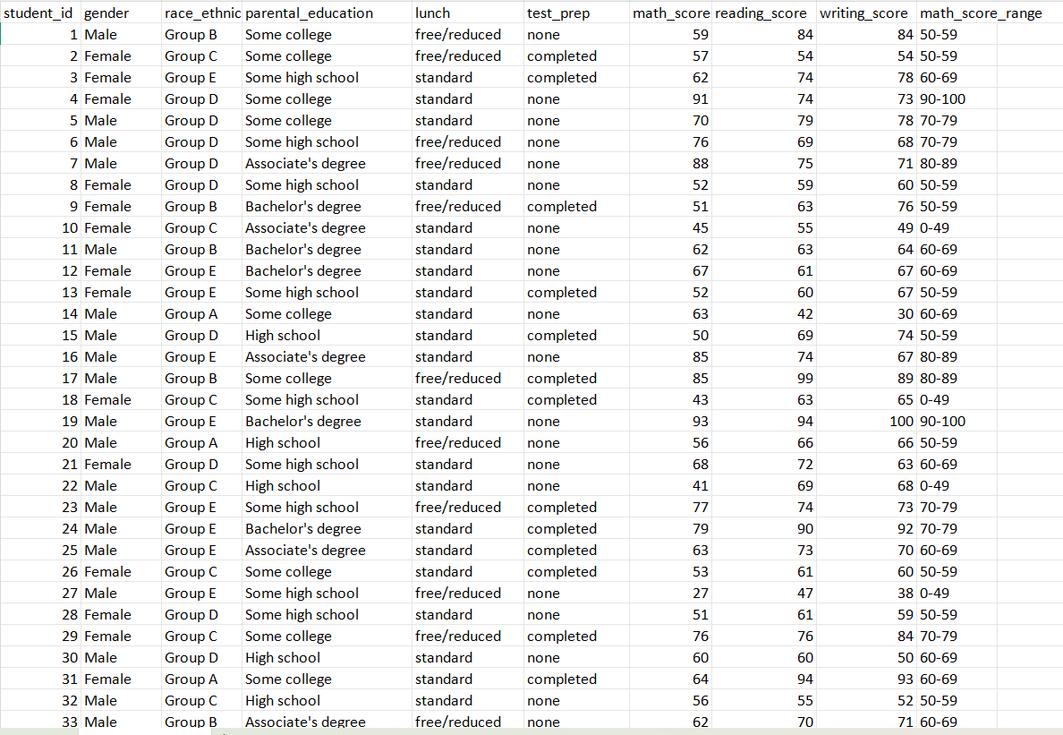

Sheet 2
Pivot Table 1: Average Scores by Gender
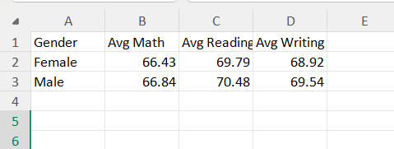

Pivot Table 2: Average Scores by Parental Education
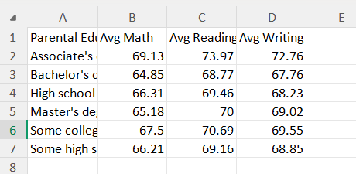

Pivot Table 3: Student Count by Test Prep & Lunch Type
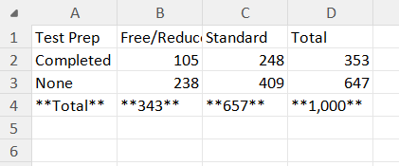
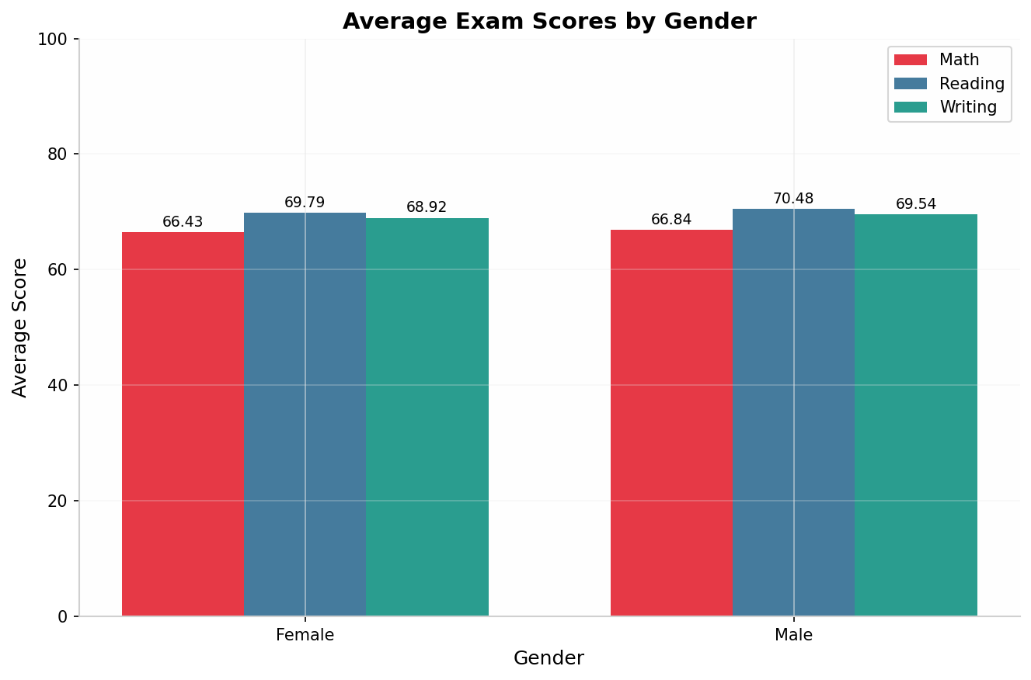
Chart 1

Chart 2

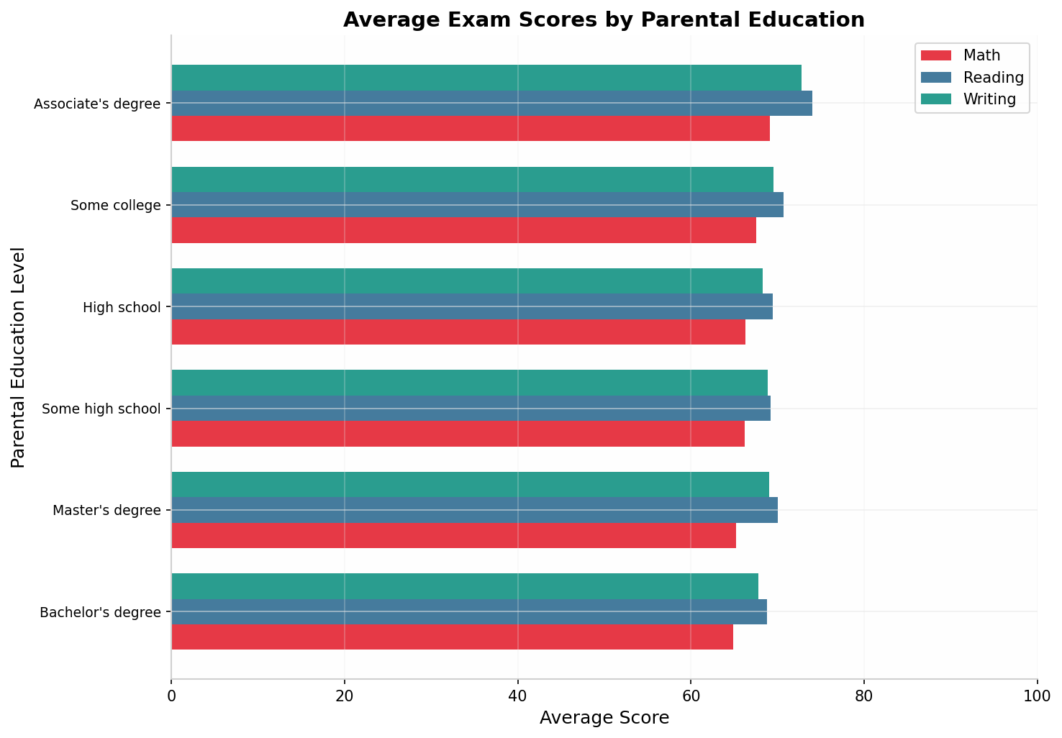

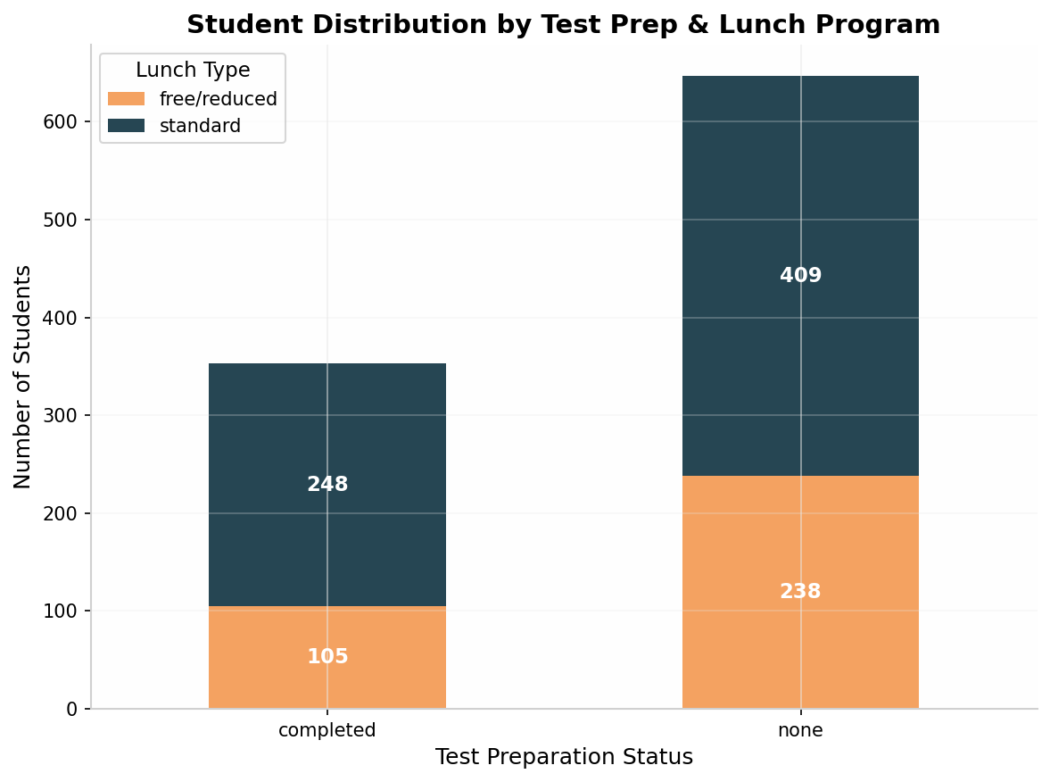
Chart 3

Formulas Showcase (5 Excel Functions
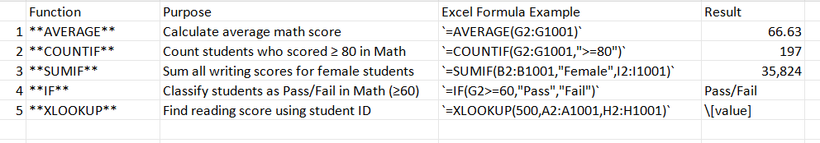
Task 2.2
Descriptive Statistics Report
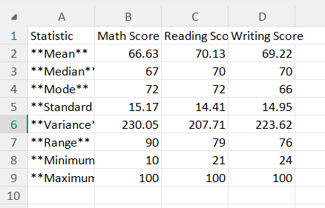

Frequency Distribution Table
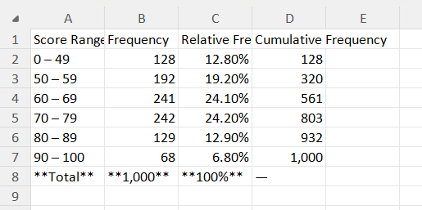

Histogram
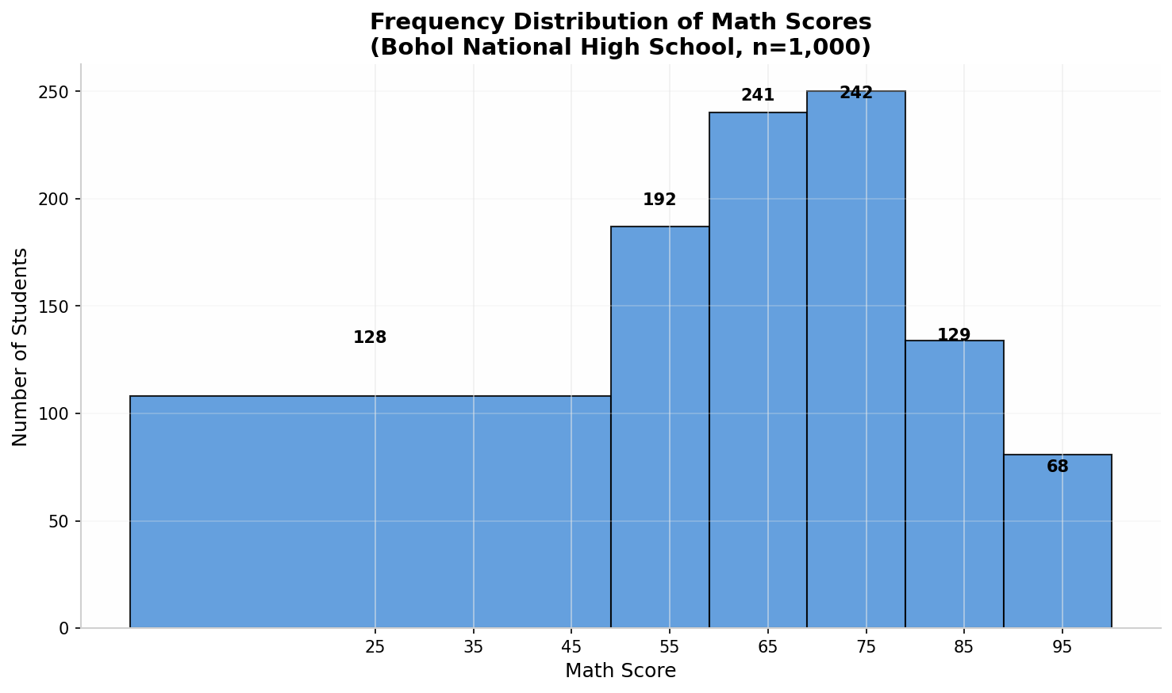

Written Interpretations

very mild left skew in the distribution. The standard deviation of 15.17 reveals moderate variability in student performance, with scores ranging from 10 to 100. The mode of 72 suggests that the most common score is above the mean, which aligns with the concentration of students in the 60–79 range (48.3% of all students). The histogram shows a roughly bell-shaped distribution centered around the mid-60s, with a noticeable tail of low-performing students below 50 who may require remedial intervention. Overall, math is the weakest subject among the three, as evidenced by its lowest mean score.
Reading Score: Reading scores show the highest mean (70.13) and median (70.00) among the three subjects, indicating that students generally perform best in reading comprehension. The standard deviation of 14.41 is the lowest, suggesting more consistent performance across the student body. The range of 79 (from 21 to 100) is narrower than math, and the distribution is more symmetric with mean and median nearly identical. The mode of 72 and the concentration of 48.4% of students in the 60–79 band confirm that reading is a relative strength for the school. The smaller variance implies that reading instruction is more uniformly effective across different student demographics.
Writing Score: Writing scores have a mean of 69.22 and a median of 70.00, placing them between math and reading in overall performance. The standard deviation of 14.95 indicates slightly more variability than reading but less than math. The range of 76 (24 to 100) is the narrowest, suggesting fewer extreme outliers at both ends. The mode of 66 is below the mean, hinting at a slight right skew where a subset of high-performing students pulls the average upward. The close alignment between reading and writing scores (mean difference of only 0.91 points) suggests strong literacy integration, where students who read well tend to write well. However, the 12.8% of students scoring below 50 in math (compared to fewer in literacy subjects) confirms that math remains the priority area for academic support.

TASK 2.3 — CORRELATION ANALYSIS
Pair 1: Math Score vs Reading Score
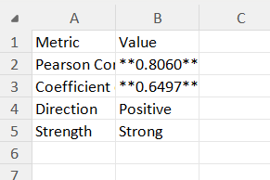

There is a strong positive correlation (r = 0.8060) between math and reading scores. This means that students who perform well in reading tend to also perform well in math, and vice versa. Approximately 65% of the variance in reading scores can be explained by math scores. For the school guidance office, this implies that literacy support programs may have a spillover benefit for math performance, and students struggling in both subjects should be prioritized for comprehensive academic intervention rather than subject-specific tutoring alone.

Excel Formula Used: =CORREL(G2:G1001,H2:H1001)
Trendline Equation: y = 0.766x + 19.095

Task 2.4
Simple Linear Regression

Model Specification
Dependent Variable (Y): Writing Score
Predictor Variable (X): Reading Score
Rationale: Since reading and writing showed the strongest correlation (r = 0.9321), reading score is the most reliable single predictor of writing performance.
Regression Output
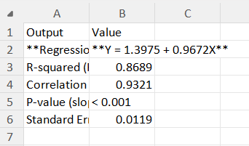

Reference scatter plot:
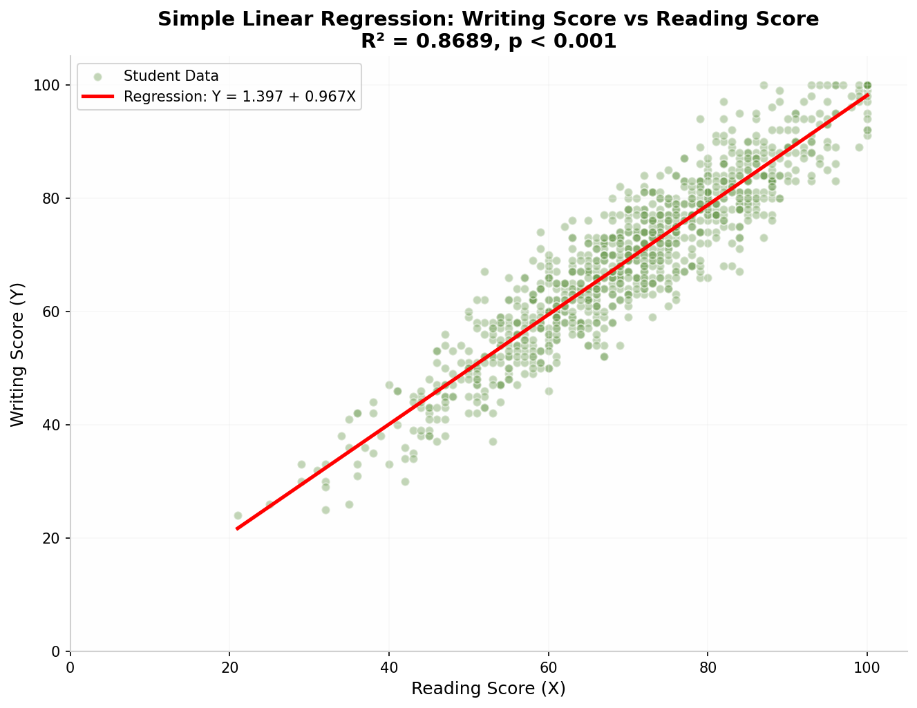

Interpretation of Results
Regression Equation: For every 1-point increase in a student's reading score, their writing score is predicted to increase by approximately 0.97 points, holding all other factors constant. The y-intercept of 1.40 represents the theoretical writing score when reading score is zero, though this has no practical interpretation since no student scored zero.
R-squared (0.8689): Approximately 86.89% of the total variation in writing scores can be explained by reading scores alone. This is an excellent fit for a simple linear regression model in educational data, indicating that reading proficiency is the dominant predictor of writing ability in this student population.

P-value (< 0.001): The slope coefficient (0.9672) is statistically significant at α = 0.05. We reject the null hypothesis that there is no relationship between reading and writing scores. The probability of observing this strong a relationship by random chance is virtually zero.

Business Predictions
Using the regression equation Y = 1.3975 + 0.9672X:

Limitations and Conditions
- Linearity Assumption: The model assumes a linear relationship between reading and writing scores. While the scatter plot shows strong linearity, there may be ceiling effects near the maximum score of 100 where the relationship flattens.
- Omitted Variable Bias: The model only uses reading score as a predictor. Other factors such as parental education, test preparation, and socioeconomic status (lunch type) also influence writing performance but are not captured here. A multiple regression model would likely improve predictive accuracy.
- Causality vs. Correlation: The model establishes association, not causation. While reading and writing skills are related, improving reading scores does not automatically guarantee equivalent writing improvement without targeted writing instruction.
- Homoscedasticity: The model assumes constant variance of residuals. At extreme high and low reading scores, the spread of writing scores may differ, potentially violating this assumption.
- Cross-sectional Data: This model is built on a single-point snapshot. Student performance changes over time, and the model cannot predict how intervention effects will evolve across semesters.

TASK 2.5 — TREND / SEASONALITY ANALYSIS
Not Applicable. The Students Performance in Exams dataset is cross-sectional rather than time-series. It contains 1,000 individual student records collected at a single point in time (one examination period) with no date or temporal variables. Therefore, trend analysis, seasonal decomposition, and time-based forecasting using Excel's FORECAST or trendline projection are not meaningful for this dataset.
Recommendation: If the school collects exam data across multiple academic years or semesters, a time-series analysis could be conducted in future checkpoints to track whether average scores are improving, declining, or stable over time. For Checkpoint 2, the regression-based predictions in Task 2.4 serve as the primary forecasting mechanism.

